Employee Attrition Analysis

Exploratory Data Analysis & Business Insights Report

1. Column Classification

Numerical Columns
Age, DailyRate, DistanceFromHome, HourlyRate, MonthlyIncome, MonthlyRate, NumCompaniesWorked, PercentSalaryHike, TotalWorkingYears, TrainingTimesLastYear, YearsAtCompany, YearsInCurrentRole, YearsSinceLastPromotion, YearsWithCurrManager.

Categorical Columns
Attrition, BusinessTravel, Department, EducationField, Gender, JobRole, MaritalStatus, OverTime.

Ordinal Columns (numeric scale, treated as categorical for segmentation)
Education, EnvironmentSatisfaction, JobInvolvement, JobLevel, JobSatisfaction, PerformanceRating, RelationshipSatisfaction, StockOptionLevel, WorkLifeBalance.

2. Key HR Metrics (KPIs)
Metric | Value
Total Employees | 1,470
Employees Who Left (Attrition = Yes) | 237
Overall Attrition Rate | 16.12%
Avg Monthly Income - Stayed | $6,833
Avg Monthly Income - Left | $4,787
Avg Tenure (Years) - Stayed | 7.37
Avg Tenure (Years) - Left | 5.13
Attrition Rate - Works Overtime | 30.53%
Attrition Rate - No Overtime | 10.44%
Attrition Rate - Low Job Satisfaction | 22.84%
Attrition Rate - Very High Job Satisfaction | 11.33%
Attrition Rate - Bad Work-Life Balance | 31.25%
Attrition Rate - Best Work-Life Balance | 17.65%
Avg Companies Worked Previously - Left | 2.94
Avg Companies Worked Previously - Stayed | 2.65

3. Exploratory Data Analysis

3.1 Overall Attrition
16.12% of employees have left the company — roughly 1 in 6. This is the baseline rate against which every segment below is compared.
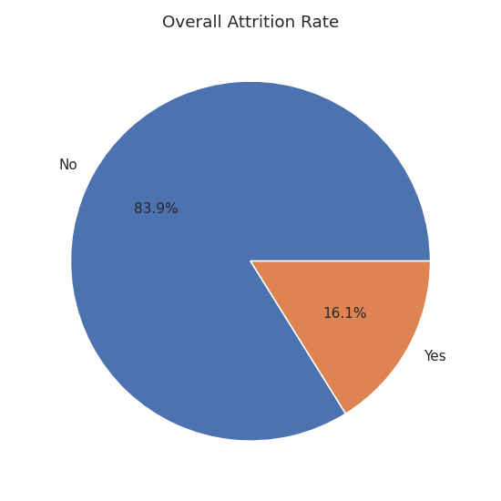

3.2 Attrition by Department & Job Role
Sales has the highest departmental attrition (20.63%), followed by HR (19.05%); R&D is comparatively stable (13.84%). At the role level, Sales Representatives stand out sharply.
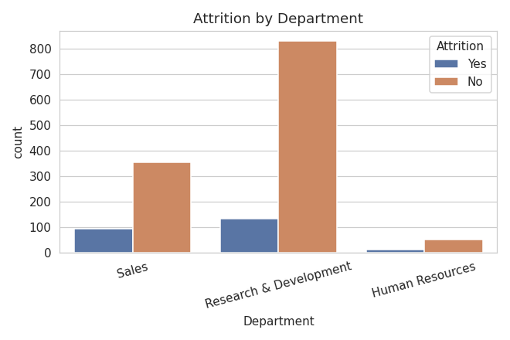
Department | Attrition Rate
Sales | 20.63%
Human Resources | 19.05%
Research & Development | 13.84%
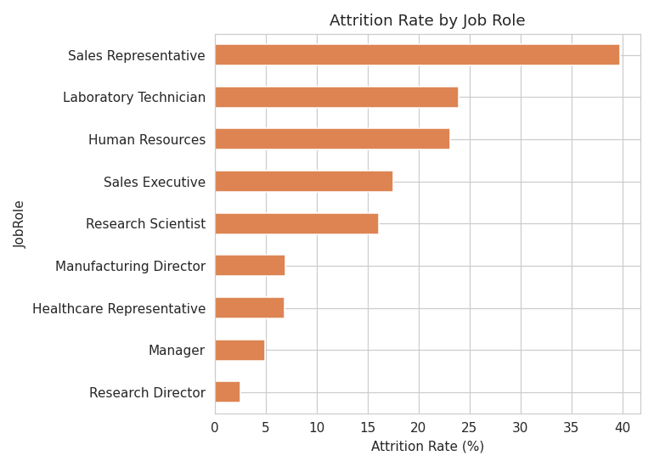
Job Role | Attrition Rate
Sales Representative | 39.76%
Laboratory Technician | 23.94%
Human Resources | 23.08%
Sales Executive | 17.48%
Research Scientist | 16.10%
Manufacturing Director | 6.90%
Healthcare Representative | 6.87%
Manager | 4.90%
Research Director | 2.50%
Sales Representative is the single highest-risk role in the company at 39.76% attrition — more than double the company average.

3.3 OverTime
Employees who work overtime leave at nearly 3x the rate of those who don't (30.53% vs 10.44%). This is one of the strongest single predictors of attrition in the dataset.
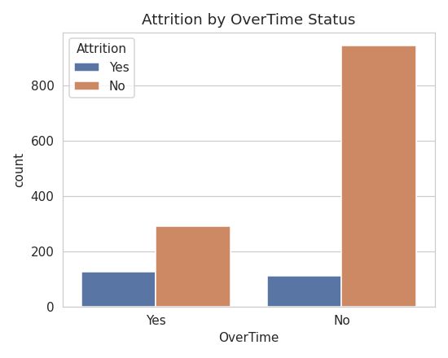

3.4 Salary / Monthly Income
Employees who left earn substantially less on average ($4,787) than those who stayed ($6,833). The boxplot shows the departing group is concentrated in the lower income band with a lower median and narrower upper range.
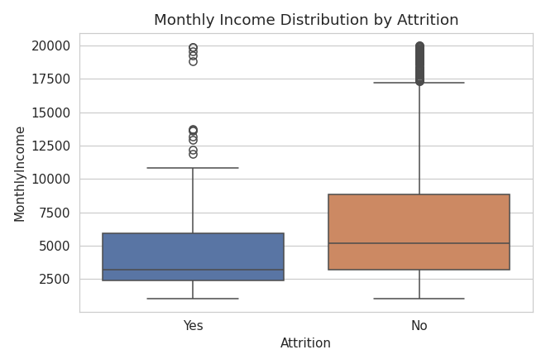

3.5 Job Satisfaction
Attrition falls steadily as job satisfaction rises: 22.84% for 'Low' satisfaction down to 11.33% for 'Very High'. Satisfaction is a strong, monotonic driver of retention.
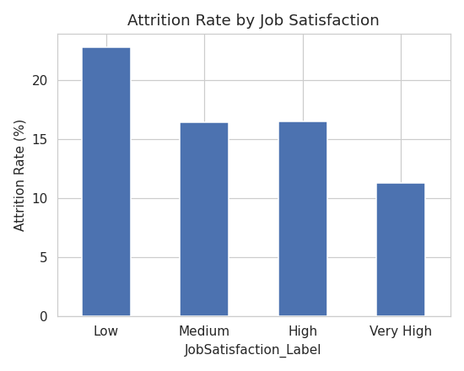

3.6 Work-Life Balance
Employees reporting 'Bad' work-life balance leave at 31.25%, nearly double the company average. Attrition drops as balance improves, though it ticks up slightly at 'Best' vs 'Better' — 'Better' seems to be the retention sweet spot, not the extreme.
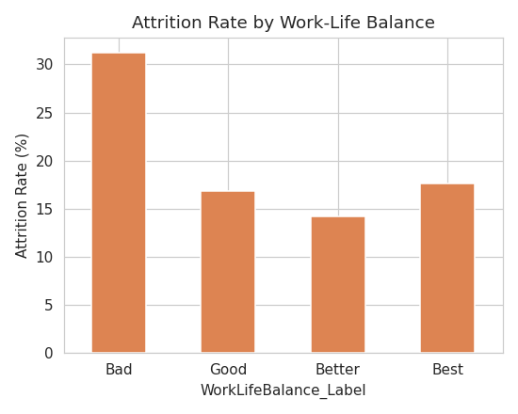

3.7 Age
Attrition skews younger — employees in their early-to-mid 20s and early 30s show visibly higher departure counts relative to their group size than employees 40+.
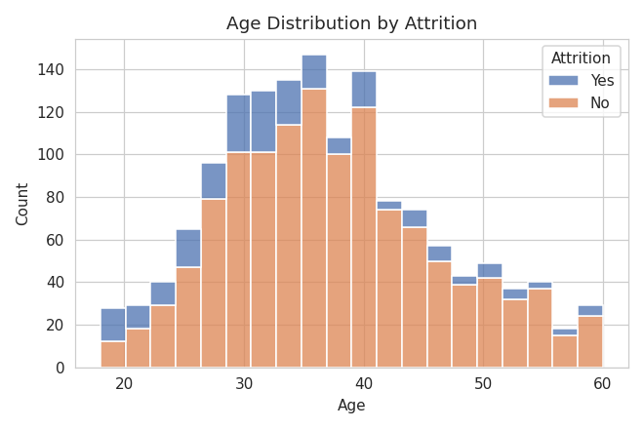

3.8 Tenure
Attrition is highest in the first 1-3 years of employment and steadily declines with tenure — the classic early-tenure flight risk pattern seen across most companies.
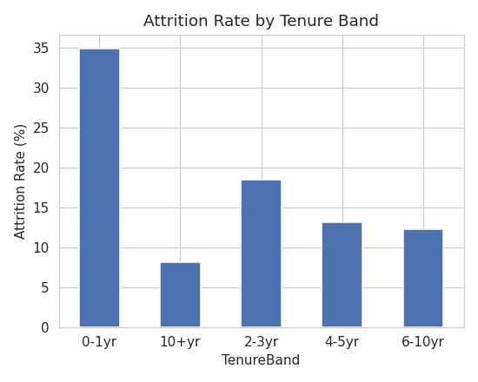

3.9 Correlation Summary
Ranking numeric fields by their correlation with attrition confirms the patterns above: tenure-related fields (YearsInCurrentRole, YearsWithCurrManager, YearsAtCompany, TotalWorkingYears, Age) correlate negatively with leaving; DistanceFromHome and NumCompaniesWorked correlate positively.
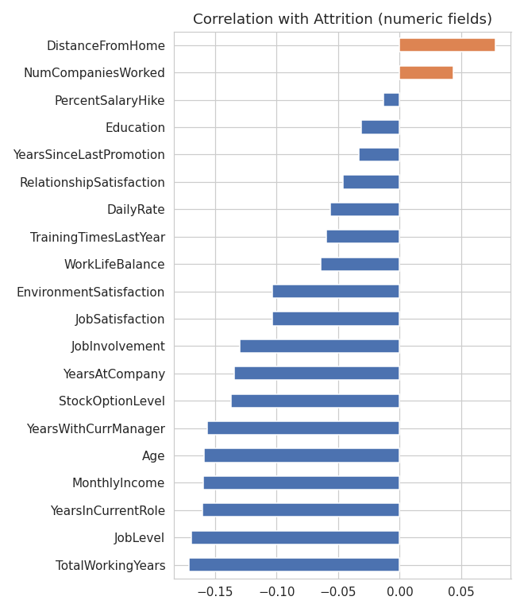

4. Business Insights (Summary)
- Overtime is the single biggest red flag — nearly 1 in 3 overtime workers leave, vs. 1 in 10 who don't.
- Compensation matters: departing employees earn ~30% less on average than those who stay.
- Sales Representatives are a critical risk group (40% attrition) — far above every other role.
- Early tenure (years 0-3) is the highest-risk window; retention risk drops sharply after year 5.
- Job satisfaction and work-life balance both show a clear inverse relationship with attrition.
- Younger employees (20s-early 30s) leave more often than employees 40+.

5. Business Recommendations
- Audit and reduce mandatory overtime, especially in Sales and Laboratory Technician roles; consider overtime pay premiums or workload redistribution.
- Review compensation bands for Sales Representatives and other high-attrition, lower-paid roles — targeted retention raises or bonuses are likely to pay back quickly given replacement costs.
- Build a structured onboarding + mentorship program for the first 3 years of tenure, when flight risk is highest.
- Run regular job-satisfaction and work-life-balance pulse surveys, with manager action plans triggered for teams scoring 'Low'/'Bad'.
- Create clearer promotion/growth pathways for younger employees, who show higher attrition despite typically being early in tenure.
- Prioritize retention interventions by segment: Sales department, Sales Representative role, overtime workers, and 0-3 year tenure employees are the four highest-leverage groups.

